Odsek Visoka ICT škola,

Akademija tehničko-umetničkih strukovnih studija,

Beograd



<https://bogdanjankovic.github.io/SenseiGames/shop.html>

# Smer: Internet tehnologije

Modul: Web programiranje

Predmet: Web programiranje 2

Bogdan Janković 83/19

# 1. Uvod

## 1.1 Korišćeni programski jezici/tehnologije

Za potrebe sajta korišćene su sledeće tehnologije:

* HTML
* CSS
* Bootstrap (samo CSS) + Font Awesome
* JavaScript + JSON + jQuery
* XML (sitemap)
* Visual Studio Code
* Photoshop

## 1.2 Opis funkcionalnosti

Funkcionalnosti sajta se mogu svrstati u sledeće kategorije:

* **Upotreba AJAX-a** za svako čitanje iz JSON fajla, ovo se realizuje asinhronim funkcijama, i ukoliko dođe do grešaka, iste se obrađuju
* **Dinamičko učitavanje navigacije** iz JSON fajla.

* **Dinamička prodavnica**, gde su proizvodi, kategorije, brendovi i aromatičnost učitani iz JSON fajla, a dostupno je filtriranje, pretraga, i sortiranje proizvoda.
* **Stranica sa informacijama o izabranom proizvodu**, koji sadrži i sve slike navedene za taj proizvod u JSON fajlu, kao i dugme za dodavanje u korpu.
* **Korpa sa količinom i ukupnim iznosom**, a klikom na dugme za poručivanje dolazi se do forme koja se validira regularnim izrazima

## 1.2 Template

Za izradu sajta nije korišćeno gotovo rešenje, sve funkcionalnosti i kod su napisani ispočetka.

# 2. Organizacija

## 2.1 Organizaciona šema

Sve stranice su međusbno dostupne jedna sa drugom.



index.html



contact.html



shop.html

Details.html

## 2.2 Mapa sajta

<urlset xmlns="http://www.sitemaps.org/schemas/sitemap/0.9" xmlns:xsi="http://www.w3.org/2001/XMLSchema-instance" xsi:schemaLocation="http://www.sitemaps.org/schemas/sitemap/0.9 http://www.sitemaps.org/schemas/sitemap/0.9/sitemap.xsd">

<url>

<loc>https://bogdanjankovic.github.io/SenseiGames/index.html</loc>

<lastmod>2022-03-13T17:26:19+00:00</lastmod>

<priority>1.00</priority>

</url>

<url>

<loc>https://bogdanjankovic.github.io/SenseiGames/cart.html</loc>

<lastmod>2022-03-13T17:26:19+00:00</lastmod>

<priority>0.80</priority>

</url>

<url>

<loc>https://bogdanjankovic.github.io/SenseiGames/shop.html</loc>

<lastmod>2022-03-13T17:26:19+00:00</lastmod>

<priority>0.80</priority>

</url>

<url>

<loc>https://bogdanjankovic.github.io/SenseiGames/detail.html</loc>

<lastmod>2022-03-13T17:26:19+00:00</lastmod>

<priority>0.80</priority>

</url>

<url>

<loc>https://bogdanjankovic.github.io/SenseiGames/contact.html</loc>

<lastmod>2022-03-13T17:26:19+00:00</lastmod>

<priority>0.80</priority>

</url>

</urlset>

## 2.3 Slike stranica i opisi funkcionalnosti

### 2.3.1 index.html

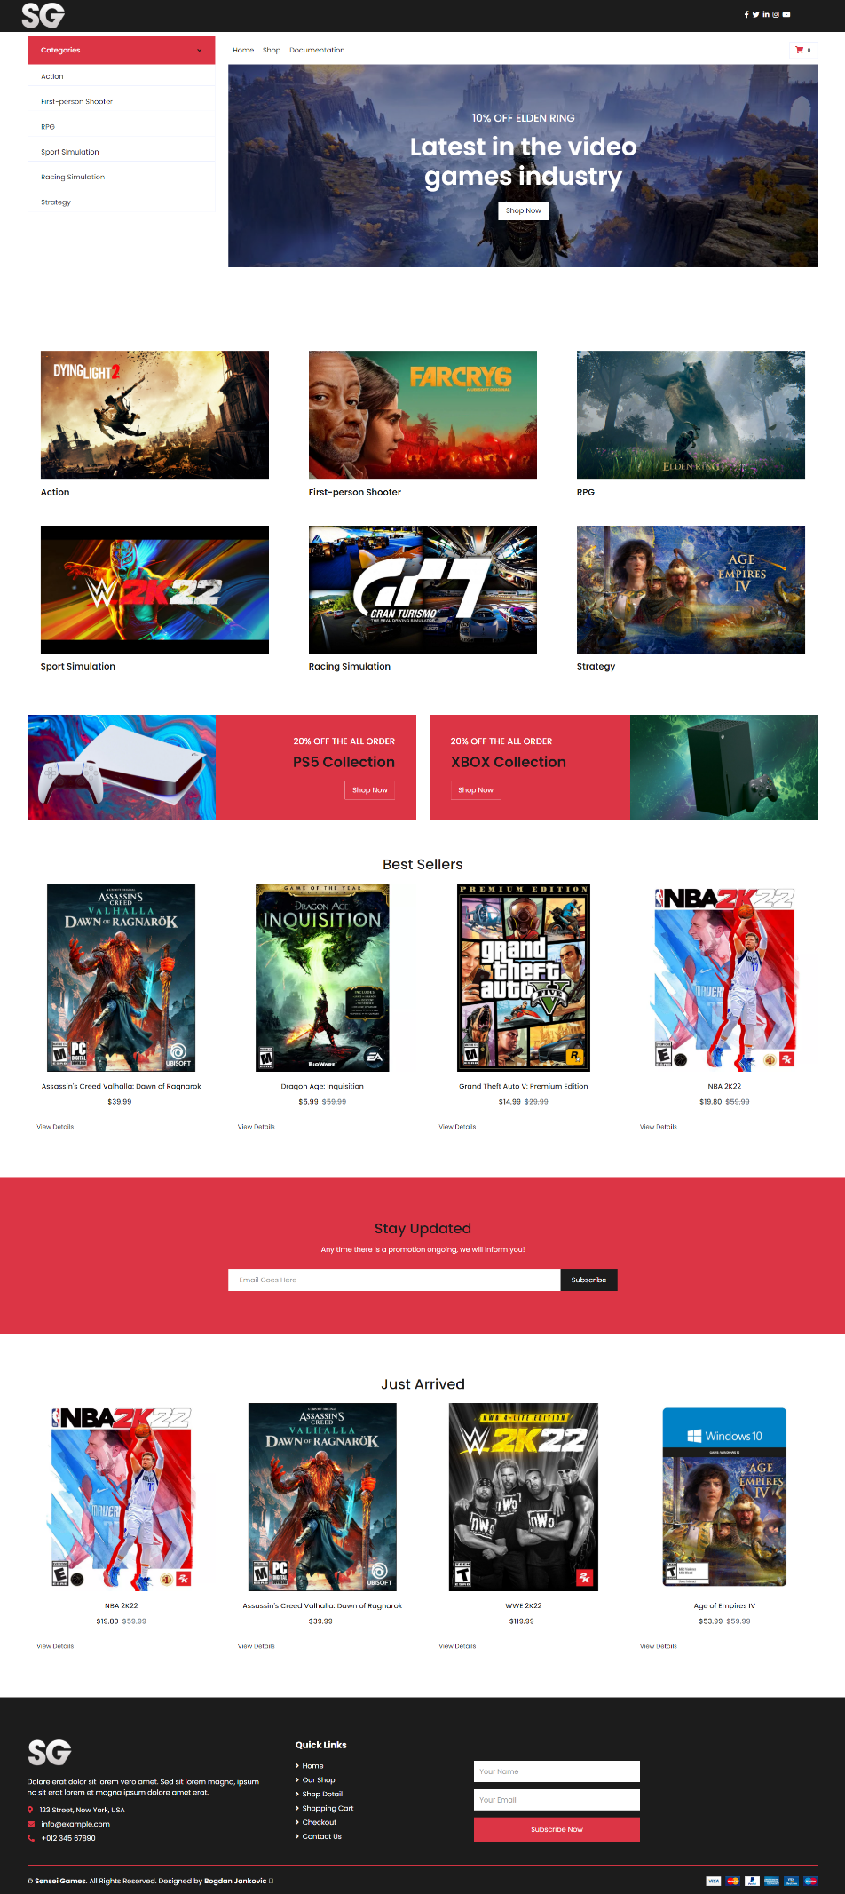

Navigacija se učitava dinamički AJAX-om iz JSON fajla, takođe prisutan je i meni za mobilne uređaje

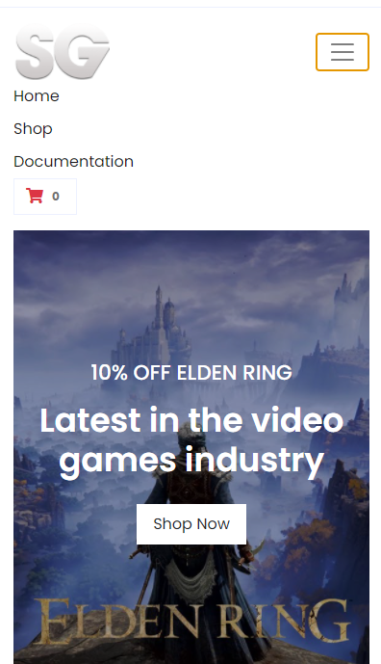

Takođe, na svakoj stranici moguće je pristupiti korpi, a sadržaj se učitava iz Local Storage (na osnovu toga šta je lokalno dodato na klijentskom delu).

Skrolovanjem se dolazi do sekcije gde se može odabrati željena kategorija proizvoda. Daljim skrolovanjem, dolazi se do dela gde se prikazuju 4 nasumična proizvoda, a ispod se nalaze najnoviji proizvodi. Klikom na View Details proizvoda otvara se details.html sa više informacija o proizvodu.

### 2.3.2 shop.html

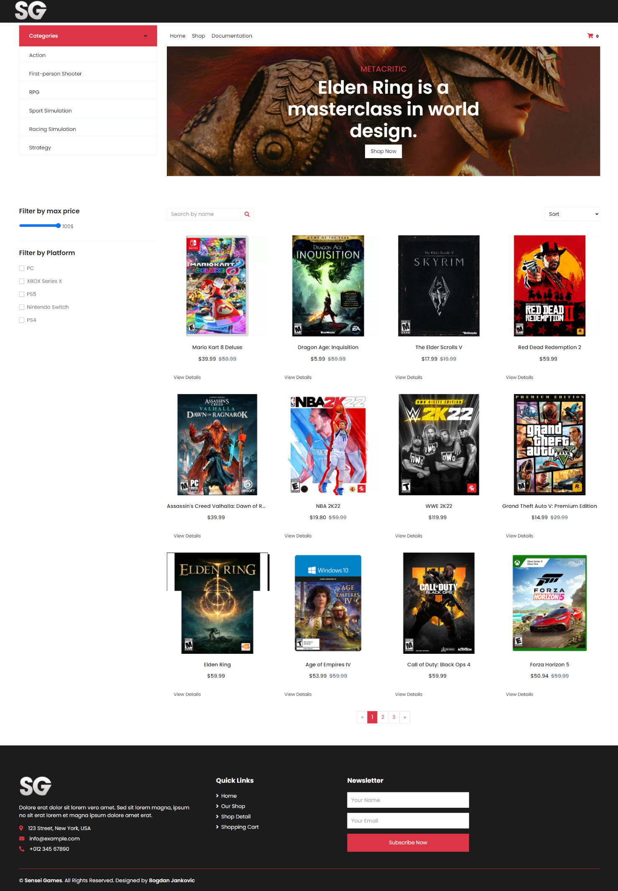

Na ovoj stranici nalaze se svi proizvodi, kao i razne opcije za filtriranje (maks. cena, platforme, kategorije), sortiranje, I pretragu. Svi proizvodi, kategorije, platforme se preuzimaju iz JSON fajlova upotrebom AJAX-a.

Takođe, korisniku se nudi da taj proizvod doda u korpu. Na taj način informacije će biti upisanje u Local Storage i biti dostupne otvaranjem korpe.



Ulaskom u korpu, prikazuju se dodati proizvodi sa opcijama brisanja i izmene količine, kao i ukupan iznos svih proizvoda.

### 2.3.3 details.html

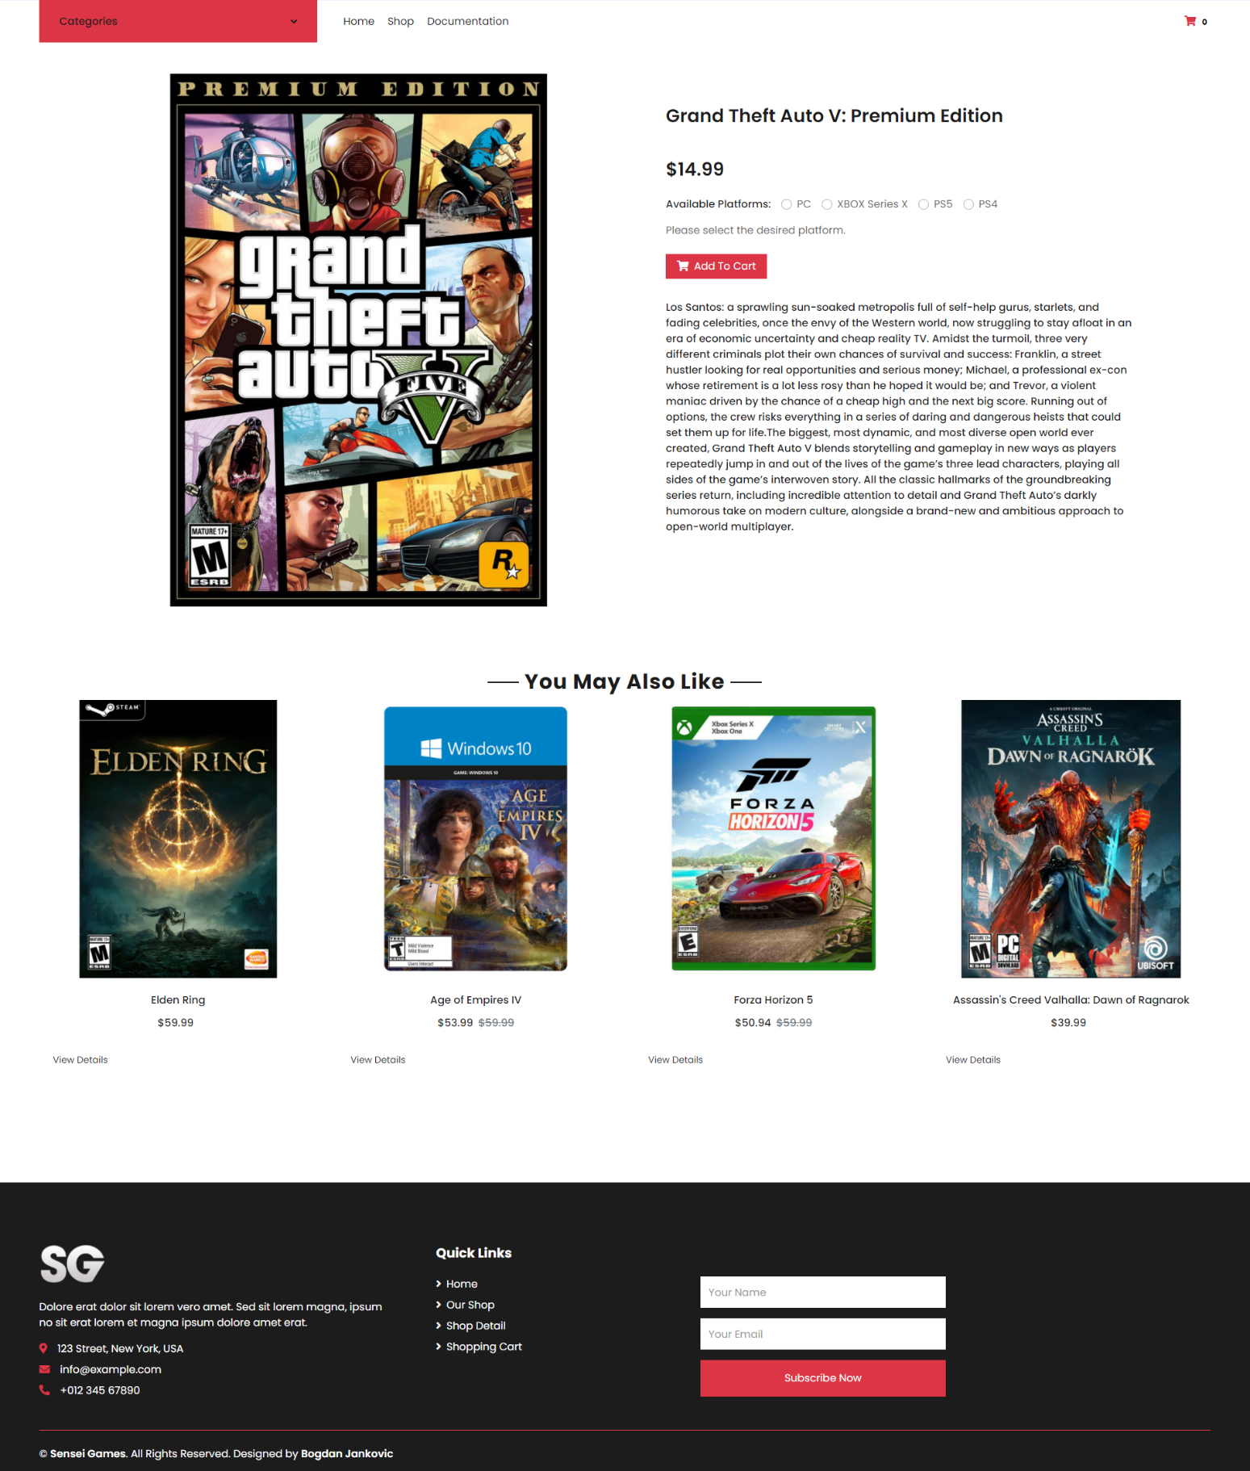

Na ovoj stranici nalaze dodatne informacije o proizvodu, platforme za koje je navedeni proizvod dostupan, kao I opcija dodavanja proizvoda u korpu. Ispod te sekcije nalazi se sekcija koja prikazuje 4 nasumična proizvoda.

### 2.3.4 cart.html

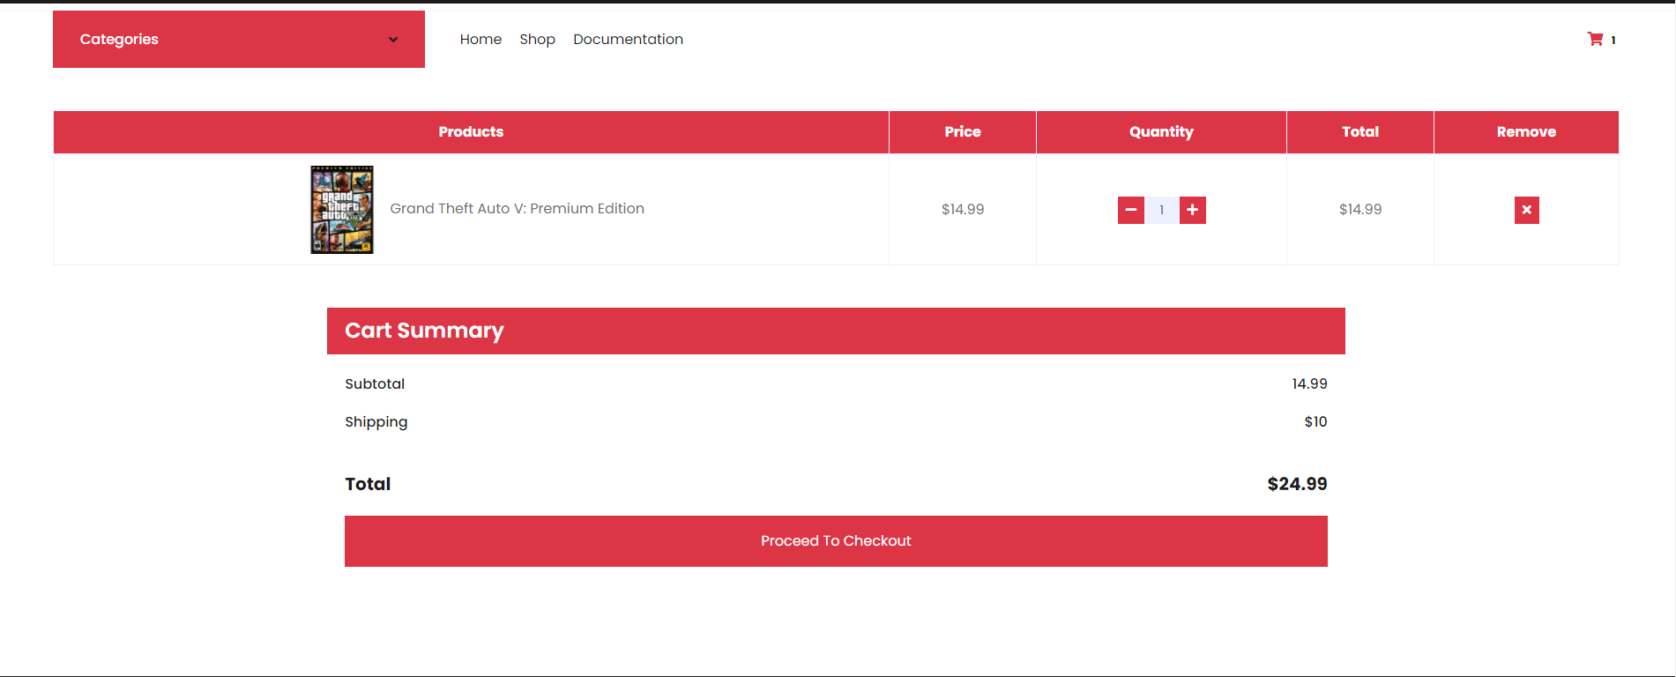

Na ovoj stranici se dinamički učitava tabela sa proizvodima prethodno unetim u korpu. Dinamički se ispisuje cena, na osnovu cene proizvoda I količine proizvoda, koja se takođe može dinamički menjati. Klikom na remove dugme izbacuje se željeni proizvod iz korpe, a ukoliko više nema proizvoda u korpi, ispisuje se tekst.



Contact.html

Na ovoj stranici nalazi se forma, na kojoj se upotrebom regularnih izraza proverava unos dva polja, i ukoliko je unos uspešan, ispisuje se odgovarajaća poruka.

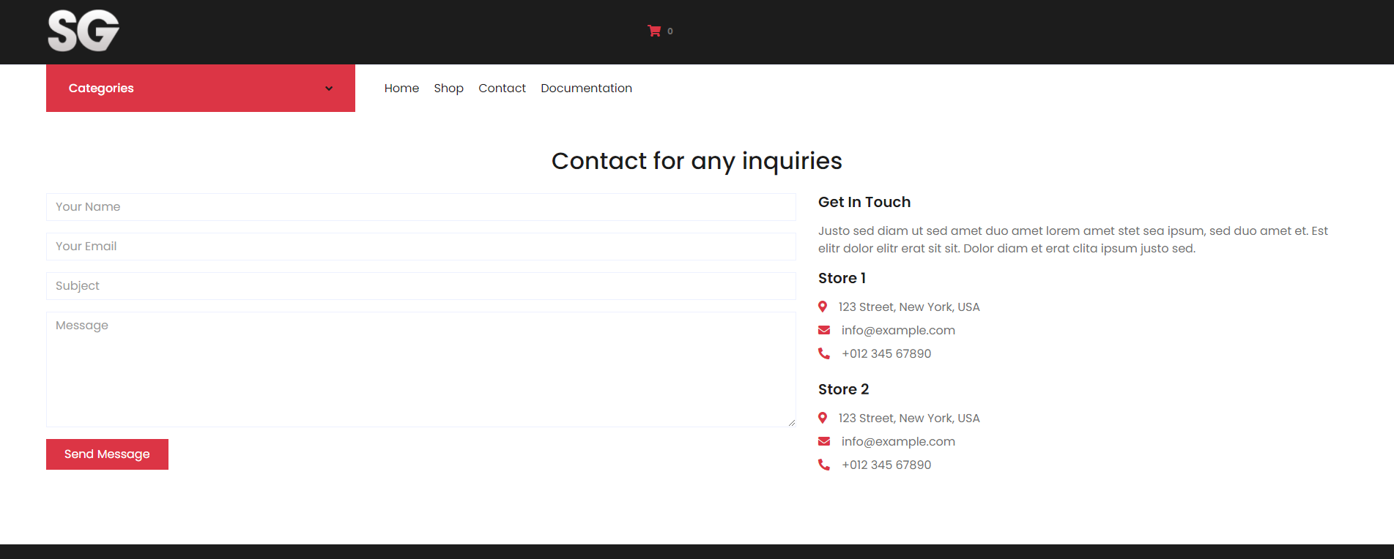

# 3. Kodovi

## 3.1 HTML

### 3.index.html

<!DOCTYPE html>

<html lang="en">

<head>

    <meta charset="utf-8">

    <title>Sensei Games</title>

    <meta content="width=device-width, initial-scale=1.0" name="viewport">

    <meta content="Video Games, Buy, Online, Exclusive" name="keywords">

    <meta content="Buy video games online at an amazing price!" name="description">

    <!-- Favicon -->

    <link href="assets/img/favicon.ico" rel="icon">

    <!-- Google Web Fonts -->

    <link rel="preconnect" href="https://fonts.gstatic.com">

    <link href="https://fonts.googleapis.com/css2?family=Poppins:wght@100;200;300;400;500;600;700;800;900&display=swap" rel="stylesheet">

    <!-- Font Awesome -->

    <link href="https://cdnjs.cloudflare.com/ajax/libs/font-awesome/5.10.0/css/all.min.css" rel="stylesheet">

    <!-- Libraries Stylesheet -->

    <link href="assets/lib/owlcarousel/assets/owl.carousel.min.css" rel="stylesheet">

    <!-- Customized Bootstrap Stylesheet -->

    <link href="assets/css/style.css" rel="stylesheet">

</head>

<body>

    <!-- Topbar Start -->

    <div class="container-fluid">

        <div class="row bg-dark py-2">

            <div class="col-lg-3 d-none d-lg-block px-5">

                <a href="index.html" class="text-decoration-none">

                    <img src="assets/img/logo.png" alt="Sensei Games" id="logoimg">

                </a>

            </div>

        </div>

        <div class="row align-items-center py-1 px-xl-5">

            <div class="col-lg-3 col-6 text-right">

            </div>

        </div>

    </div>

    <!-- Topbar End -->

    <!-- Navbar Start -->

    <div class="container-fluid mb-5">

        <div class="row border-top px-xl-5">

            <div class="col-lg-3 d-none d-lg-block">

                <a class="btn shadow-none d-flex align-items-center justify-content-between bg-danger text-white w-100" data-toggle="collapse" href="#navbar-vertical" style="height: 65px; margin-top: -1px; padding: 0 30px;">

                    <h6 class="m-0 text-white">Categories</h6>

                    <i class="fa fa-angle-down text-dark"></i>

                </a>

                <nav class="collapse show navbar navbar-vertical navbar-light align-items-start p-0 border border-top-0 border-bottom-0" id="navbar-vertical">

                    <div class="navCatMenu navbar-nav w-100 overflow-hidden" style="height: 335px">

                    </div>

                </nav>

            </div>

            <div class="col-lg-9">

                <nav class="navbar navbar-expand-lg bg-light navbar-light py-3 py-lg-0 px-0">

                    <a href="" class="text-decoration-none d-block d-lg-none">

                        <img src="assets/img/logo.png" alt="Sensei Games" id="logoimg">

                    </a>

                    <button type="button" class="navbar-toggler" data-toggle="collapse" data-target="#navbarCollapse">

                        <span class="navbar-toggler-icon"></span>

                    </button>

                    <div class="collapse navbar-collapse justify-content-between" id="navbarCollapse">

                        <div class="menu navbar-nav mr-auto py-0">

                        </div>

                        <a href="cart.html">

                            <i class="fas fa-shopping-cart text-danger"></i>

                            <span class="badge">0</span>

                        </a>

                    </div>

                </nav>

                <div id="header-carousel" class="carousel slide" data-ride="carousel">

                    <div id="carousel" class="carousel-inner">

                        <div class="carousel-item active" style="height: 460px;">

                            <img class="img-fluid" src="assets/img/maxresdefault.jpg" alt="Elden ring">

                            <div class="carousel-caption d-flex flex-column align-items-center justify-content-center">

                                <div class="p-3" style="max-width: 700px;">

                                    <h4 class="text-light text-uppercase font-weight-medium mb-3">10% Off Elden Ring</h4>

                                    <h3 class="display-4 text-white font-weight-semi-bold mb-4">Latest in the video games industry</h3>

                                    <a href="" class="btn btn-light py-2 px-3">Shop Now</a>

                                </div>

                            </div>

                        </div>

                    </div>

                </div>

            </div>

        </div>

    </div>

    <!-- Navbar End -->

    <!-- Featured Start -->

    <div class="container-fluid pt-5">

        <div id="featured" class="row px-xl-5 pb-3">

        </div>

    </div>

    <!-- Featured End -->

    <!-- Categories Start -->

    <div class="container-fluid pt-5">

        <div id="catCover" class="row px-xl-5 pb-3">

        </div>

    </div>

    <!-- Categories End -->

    <!-- Offer Start -->

    <div class="container-fluid offer pt-5">

        <div class="row px-xl-5">

            <div class="col-md-6 pb-4">

                <div class="position-relative bg-danger text-center text-md-right text-white mb-2 py-5 px-5">

                    <img src="assets/img/ps5-event-everything-announced-and-revealed_c2d3.jpg" alt="PS5">

                    <div class="position-relative" style="z-index: 1;">

                        <h5 class="text-uppercase text-light mb-3">BROWSE OUR</h5>

                        <h2 class="mb-4 font-weight-semi-bold">PS5 Collection</h2>

                        <a href="shop.html" class="btn btn-outline-light py-md-2 px-md-3">Shop Now</a>

                    </div>

                </div>

            </div>

            <div class="col-md-6 pb-4">

                <div class="position-relative bg-danger text-center text-md-left text-white mb-2 py-5 px-5">

                    <img src="assets/img/xboxseriesx-blogroll-1600758953687_160w.jpg" alt="XBOX Series X">

                    <div class="position-relative" style="z-index: 1;">

                        <h5 class="text-uppercase text-light mb-3">BROWSE OUR</h5>

                        <h2 class="mb-4 font-weight-semi-bold">XBOX Collection</h2>

                        <a href="shop.html" class="btn btn-outline-light py-md-2 px-md-3">Shop Now</a>

                    </div>

                </div>

            </div>

        </div>

    </div>

    <!-- Offer End -->

    <!-- Products Start -->

    <div class="container-fluid pt-5">

        <div class="text-center mb-4">

            <h2 class=" px-5"><span class="px-2">Best Sellers</span></h2>

        </div>

        <div id="bestSellingProducts" class="row px-xl-5 pb-3">

        </div>

    </div>

    <!-- Products End -->

    <!-- Subscribe Start -->

    <div class="container-fluid bg-danger my-5">

        <div class="row justify-content-md-center py-5 px-xl-5">

            <div class="col-md-6 col-12 py-5">

                <div class="text-center mb-2 pb-2">

                    <h2 class="px-5 mb-3">Stay Updated</h2>

                    <p class="text-white">Any time there is a promotion ongoing, we will inform you!</p>

                </div>

                <form action="">

                    <div class="input-group">

                        <input type="text" class="form-control border-white p-4" placeholder="Email Goes Here">

                        <div class="input-group-append">

                            <button class="btn btn-dark px-4">Subscribe</button>

                        </div>

                    </div>

                </form>

            </div>

        </div>

    </div>

    <!-- Subscribe End -->

    <!-- Products Start -->

    <div class="container-fluid pt-5">

        <div class="text-center mb-4">

            <h2 class="px-5"><span class="px-2">Just Arrived</span></h2>

        </div>

        <div id="justArrivedProducts" class="row px-xl-5 pb-3">

        </div>

    </div>

    <!-- Products End -->

    <!-- Footer Start -->

    <div class="container-fluid bg-dark text-white mt-5 pt-5">

        <div class="row px-xl-5 pt-5">

            <div class="col-lg-4 col-md-12 mb-5 pr-3 pr-xl-5">

                <a href="" class="text-decoration-none ">

                    <img src="assets/img/logo.png" alt="Sensei Games" id="logoimg">

                </a>

                <p class="pt-4">Dolore erat dolor sit lorem vero amet. Sed sit lorem magna, ipsum no sit erat lorem et magna ipsum dolore amet erat.</p>

                <p class="mb-2"><i class="fa fa-map-marker-alt text-danger mr-3"></i>123 Street, New York, USA</p>

                <p class="mb-2"><i class="fa fa-envelope text-danger mr-3"></i>info@example.com</p>

                <p class="mb-0"><i class="fa fa-phone-alt text-danger mr-3"></i>+012 345 67890</p>

            </div>

            <div class="col-lg-8 col-md-12">

                <div class="row">

                    <div class="col-md-4 mb-5">

                        <h5 class="font-weight-bold text-white mb-4">Quick Links</h5>

                        <div class="d-flex flex-column justify-content-start">

                            <a class="text-white mb-2" href="index.html"><i class="fa fa-angle-right mr-2"></i>Home</a>

                            <a class="text-white mb-2" href="shop.html"><i class="fa fa-angle-right mr-2"></i>Our Shop</a>

                            <a class="text-white mb-2" href="detail.html"><i class="fa fa-angle-right mr-2"></i>Shop Detail</a>

                            <a class="text-white mb-2" href="cart.html"><i class="fa fa-angle-right mr-2"></i>Shopping Cart</a>

                        </div>

                    </div>

                    <div class="col-md-4 mb-5">

                        <h5 class="font-weight-bold text-dark mb-4">Newsletter</h5>

                        <form action="">

                            <div class="form-group">

                                <input type="text" class="form-control border-0 py-4" placeholder="Your Name" required="required" />

                            </div>

                            <div class="form-group">

                                <input type="email" class="form-control border-0 py-4" placeholder="Your Email"

                                    required="required" />

                            </div>

                            <div>

                                <button class="btn btn-danger btn-block border-0 py-3" type="submit">Subscribe Now</button>

                            </div>

                        </form>

                    </div>

                </div>

            </div>

        </div>

        <div class="row border-top border-danger mx-xl-5 py-4">

            <div class="col-md-6 px-xl-0">

                <p class="mb-md-0 text-center text-md-left text-white">

                    &copy; <a class="text-white font-weight-semi-bold" href="#">Sensei Games</a>. All Rights Reserved. Designed

                    by

                    <a class="text-white font-weight-semi-bold" href="https://bogdanjankovic.github.io/portfolio/">Bogdan Jankovic</a>

                    <a class="text-white font-weight-semi-bold" href="sitemap.xml"><i class="fas-solid fa-sitemap"></i></a>

                </p>

            </div>

            <div class="col-md-6 px-xl-0 text-center text-md-right">

                <img class="img-fluid" src="assets/img/payments.png" alt="">

            </div>

        </div>

    </div>

    <!-- Footer End -->

    <!-- Back to Top -->

    <a href="#" class="btn btn-danger back-to-top"><i class="fa fa-angle-double-up"></i></a>

    <!-- JavaScript Libraries -->

    <script src="https://code.jquery.com/jquery-3.4.1.min.js"></script>

    <script src="https://stackpath.bootstrapcdn.com/bootstrap/4.4.1/js/bootstrap.bundle.min.js"></script>

    <script src="assets/lib/easing/easing.min.js"></script>

    <script src="assets/lib/owlcarousel/owl.carousel.min.js"></script>

    <!-- Contact Javascript File -->

    <script src="assets/mail/jqBootstrapValidation.min.js"></script>

    <script src="assets/mail/contact.js"></script>

    <!-- Template Javascript -->

    <script src="assets/js/main.js"></script>

    <script src="assets/js/code.js"></script>

</body>

</html>

Shop.html

<!DOCTYPE html>

<html lang="en">

<head>

    <meta charset="utf-8">

    <title>SenseiGames Shop</title>

    <meta content="width=device-width, initial-scale=1.0" name="viewport">

    <meta content="PS5, XBOX Series X, Nintendo Switch, PC, Games, Buy" name="keywords">

    <meta content="Buy PS5, Xbox Series X, Nintendo Switch, PC and other games for a sweet price!" name="description">

    <!-- Favicon -->

    <link href="assets/img/favicon.ico" rel="icon">

    <!-- Google Web Fonts -->

    <link rel="preconnect" href="https://fonts.gstatic.com">

    <link href="https://fonts.googleapis.com/css2?family=Poppins:wght@100;200;300;400;500;600;700;800;900&display=swap" rel="stylesheet">

    <!-- Font Awesome -->

    <link href="https://cdnjs.cloudflare.com/ajax/libs/font-awesome/5.10.0/css/all.min.css" rel="stylesheet">

    <!-- Libraries Stylesheet -->

    <link href="assets/lib/owlcarousel/assets/owl.carousel.min.css" rel="stylesheet">

    <!-- Customized Bootstrap Stylesheet -->

    <link href="assets/css/style.css" rel="stylesheet">

</head>

<body>

     <!-- Topbar Start -->

    <div class="container-fluid">

        <div class="row bg-dark py-2">

            <div class="col-lg-3 d-none d-lg-block px-5">

                <a href="index.html" class="text-decoration-none">

                    <img src="assets/img/logo.png" alt="Sensei Games" id="logoimg">

                </a>

            </div>

        </div>

        <div class="row align-items-center py-1 px-xl-5">

            <!--<div class="col-lg-6 col-6 text-left">

                <form action="">

                    <div class="input-group">

                        <input type="text" class="form-control" placeholder="Search for products">

                        <div class="input-group-append">

                            <span class="input-group-text bg-transparent text-primary">

                                <i class="fa fa-search"></i>

                            </span>

                        </div>

                    </div>

                </form>

            </div>-->

            <div class="col-lg-3 col-6 text-right">

                <!--<a href="" class="btn border">

                    <i class="fas fa-heart text-primary"></i>

                    <span class="badge">0</span>

                </a>-->

            </div>

        </div>

    </div>

    <!-- Topbar End -->

    <!-- Navbar Start -->

    <div class="container-fluid mb-5">

        <div class="row border-top px-xl-5">

            <div class="col-lg-3 d-none d-lg-block">

                <a class="btn shadow-none d-flex align-items-center justify-content-between bg-danger text-white w-100" data-toggle="collapse" href="#navbar-vertical" style="height: 65px; margin-top: -1px; padding: 0 30px;">

                    <h6 class="m-0 text-white">Categories</h6>

                    <i class="fa fa-angle-down text-dark"></i>

                </a>

                <nav class="collapse show navbar navbar-vertical navbar-light align-items-start p-0 border border-top-0 border-bottom-0" id="navbar-vertical">

                    <div class="navCatMenu navbar-nav w-100 overflow-hidden" style="height: 335px">

                    </div>

                </nav>

            </div>

            <div class="col-lg-9">

                <nav class="navbar navbar-expand-lg bg-light navbar-light py-3 py-lg-0 px-0">

                    <a href="" class="text-decoration-none d-block d-lg-none">

                        <img src="assets/img/logo.png" alt="Sensei Games" id="logoimg">

                    </a>

                    <button type="button" class="navbar-toggler" data-toggle="collapse" data-target="#navbarCollapse">

                        <span class="navbar-toggler-icon"></span>

                    </button>

                    <div class="collapse navbar-collapse justify-content-between" id="navbarCollapse">

                        <div class="menu navbar-nav mr-auto py-0">

                        </div>

                        <a href="cart.html" >

                            <i class="fas fa-shopping-cart text-danger"></i>

                            <span class="badge">0</span>

                        </a>

                    </div>

                </nav>

                <!-- Page Header Start -->

    <div id="header-carousel" class="carousel slide" data-ride="carousel">

        <div id="carousel" class="carousel-inner">

            <div class="carousel-item active" style="height: 400px;">

                <div class="carousel-caption d-flex flex-column align-items-center justify-content-center">

                    <div class="p-3" style="max-width: 800px;">

                        <h4 class="text-danger text-uppercase font-weight-medium mb-2">Metacritic</h4>

                        <h3 class="display-4 text-white font-weight-semi-bold mb-2">Elden Ring is a masterclass in world design.</h3>

                        <a href="" class="btn btn-light py-2 px-3">Shop Now</a>

                    </div>

                </div>

            </div>

        </div>

                </div>

            </div>

        </div>

    </div>

    <!-- Navbar End -->

    <!-- Shop Start -->

    <div class="container-fluid pt-5">

        <div class="row px-xl-5">

            <!-- Shop Sidebar Start -->

            <div class="col-lg-3 col-md-12">

                <!-- Price Start -->

                <div class="border-bottom mb-4 pb-4">

                    <h5 class="font-weight-semi-bold mb-4">Filter by max price</h5>

                    <form>

                        <div>

                        <input type="range" id="range" name="range" min="0" max="100" value="100" step="10">

                        <label id="rangeValue" for="range">100$</label>

                        </div>

                    </form>

                </div>

                <!-- Price End -->

                <!-- Size Start -->

                <div class="mb-5">

                    <h5 class="font-weight-semi-bold mb-4">Filter by Platform</h5>

                    <form id="platformForm">

                    </form>

                </div>

                <!-- Size End -->

            </div>

            <!-- Shop Sidebar End -->

            <!-- Shop Product Start -->

            <div class="col-lg-9 col-md-12">

                <div class="row pb-3">

                    <div class="col-12 pb-1">

                        <div class="d-flex align-items-center justify-content-between mb-4">

                            <form action="">

                                <div class="input-group">

                                    <input type="text" class="form-control" id="searchName" placeholder="Search by name">

                                    <div class="input-group-append">

                                        <span class="input-group-text bg-transparent text-danger">

                                            <i class="fa fa-search"></i>

                                        </span>

                                    </div>

                                </div>

                            </form>

                            <!--<div class="dropdown ml-4">

                                <button class="btn border dropdown-toggle" type="button" id="triggerId" data-toggle="dropdown" aria-haspopup="true"

                                        aria-expanded="false">

                                            Sort by

                                        </button>

                                <div class="dropdown-menu dropdown-menu-right" aria-labelledby="triggerId">

                                    <a class="dropdown-item" id="priceAsc" href="#">Price low to high</a>

                                    <a class="dropdown-item" id="priceDesc" href="#">Price high to low</a>

                                    <a class="dropdown-item" id="namesDesc" href="#">Names A-Z</a>

                                    <a class="dropdown-item" id="namesAsc" href="#">Names Z-A</a>

                                </div>

                            </div>-->

                            <div class="dropdown ml-4">

                                <select id="sort" class="border dropdown-toggle p-2">

                                    <option class="dropdown-item" hidden value="default">Sort</option>

                                    <option class="dropdown-item" value="priceAsc">Price low to high</option>

                                    <option class="dropdown-item" value="priceDesc">Price high to low</option>

                                    <option class="dropdown-item" value="namesAsc">Names A-Z</option>

                                    <option class="dropdown-item" value="namesDesc">Names Z-A</option>

                                </select>

                                </div>

                            </div>

                        </div>

                    </div>

                    <div id="products" class="row"></div>

                    <div class="col-12 pb-1">

                        <nav aria-label="Page navigation">

                          <ul class="pagination justify-content-center mb-3">

                            <li class="page-item disabled">

                              <a class="page-link" href="#" aria-label="Previous">

                                <span aria-hidden="true">&laquo;</span>

                                <span class="sr-only">Previous</span>

                              </a>

                            </li>

                            <li class="page-item active"><a class="page-link" href="#">1</a></li>

                            <li class="page-item"><a class="page-link" href="#">2</a></li>

                            <li class="page-item"><a class="page-link" href="#">3</a></li>

                            <li class="page-item">

                              <a class="page-link" href="#" aria-label="Next">

                                <span aria-hidden="true">&raquo;</span>

                                <span class="sr-only">Next</span>

                              </a>

                            </li>

                          </ul>

                        </nav>

                    </div>

                </div>

            </div>

            <!-- Shop Product End -->

        </div>

    </div>

    <!-- Shop End -->

     <!-- Footer Start -->

     <div class="container-fluid bg-dark text-white mt-5 pt-5">

        <div class="row px-xl-5 pt-5">

            <div class="col-lg-4 col-md-12 mb-5 pr-3 pr-xl-5">

                <a href="index.html" class="text-decoration-none ">

                    <img src="assets/img/logo.png" alt="Sensei Games" id="logoimg">

                </a>

                <p class="pt-4">Dolore erat dolor sit lorem vero amet. Sed sit lorem magna, ipsum no sit erat lorem et magna ipsum dolore amet erat.</p>

                <p class="mb-2"><i class="fa fa-map-marker-alt text-danger mr-3"></i>123 Street, New York, USA</p>

                <p class="mb-2"><i class="fa fa-envelope text-danger mr-3"></i>info@example.com</p>

                <p class="mb-0"><i class="fa fa-phone-alt text-danger mr-3"></i>+012 345 67890</p>

            </div>

            <div class="col-lg-8 col-md-12">

                <div class="row">

                    <div class="col-md-4 mb-5">

                        <h5 class="font-weight-bold text-white mb-4">Quick Links</h5>

                        <div class="d-flex flex-column justify-content-start">

                            <a class="text-white mb-2" href="index.html"><i class="fa fa-angle-right mr-2"></i>Home</a>

                            <a class="text-white mb-2" href="shop.html"><i class="fa fa-angle-right mr-2"></i>Our Shop</a>

                            <a class="text-white mb-2" href="detail.html"><i class="fa fa-angle-right mr-2"></i>Shop Detail</a>

                            <a class="text-white mb-2" href="cart.html"><i class="fa fa-angle-right mr-2"></i>Shopping Cart</a>

                        </div>

                    </div>

                    <div class="col-md-4 mb-5">

                        <h5 class="font-weight-bold text-white mb-4">Newsletter</h5>

                        <form action="">

                            <div class="form-group">

                                <input type="text" class="form-control border-0 py-4" placeholder="Your Name" required="required" />

                            </div>

                            <div class="form-group">

                                <input type="email" class="form-control border-0 py-4" placeholder="Your Email"

                                    required="required" />

                            </div>

                            <div>

                                <button class="btn btn-danger btn-block border-0 py-3" type="submit">Subscribe Now</button>

                            </div>

                        </form>

                    </div>

                </div>

            </div>

        </div>

        <div class="row border-top border-danger mx-xl-5 py-4">

            <div class="col-md-6 px-xl-0">

                <p class="mb-md-0 text-center text-md-left text-white">

                    &copy; <a class="text-white font-weight-semi-bold" href="#">Sensei Games</a>. All Rights Reserved. Designed

                    by

                    <a class="text-white font-weight-semi-bold" href="https://bogdanjankovic.github.io/portfolio/">Bogdan Jankovic</a>

                </p>

            </div>

        </div>

    </div>

    <!-- Footer End -->

    <!-- Back to Top -->

    <a href="#" class="btn btn-danger back-to-top"><i class="fa fa-angle-double-up"></i></a>

    <!-- JavaScript Libraries -->

    <script src="https://code.jquery.com/jquery-3.4.1.min.js"></script>

    <script src="https://stackpath.bootstrapcdn.com/bootstrap/4.4.1/js/bootstrap.bundle.min.js"></script>

    <script src="assets/lib/easing/easing.min.js"></script>

    <script src="assets/lib/owlcarousel/owl.carousel.min.js"></script>

    <!-- Contact Javascript File -->

    <script src="assets/mail/jqBootstrapValidation.min.js"></script>

    <script src="assets/mail/contact.js"></script>

    <!-- Template Javascript -->

    <script src="assets/js/main.js"></script>

    <script src="assets/js/code.js"></script>

</body>

</html>

Details.html

<!DOCTYPE html>

<html lang="en">

<head>

    <meta charset="utf-8">

    <title>Sensei Games - Product Details</title>

    <meta content="width=device-width, initial-scale=1.0" name="viewport">

    <meta content="Buy, Game, Discount" name="keywords">

    <meta content="Buy this game at a nice discount!" name="description">

    <!-- Favicon -->

    <link href="assets/img/favicon.ico" rel="icon">

    <!-- Google Web Fonts -->

    <link rel="preconnect" href="https://fonts.gstatic.com">

    <link href="https://fonts.googleapis.com/css2?family=Poppins:wght@100;200;300;400;500;600;700;800;900&display=swap" rel="stylesheet">

    <!-- Font Awesome -->

    <link href="https://cdnjs.cloudflare.com/ajax/libs/font-awesome/5.10.0/css/all.min.css" rel="stylesheet">

    <!-- Libraries Stylesheet -->

    <link href="assets/lib/owlcarousel/assets/owl.carousel.min.css" rel="stylesheet">

    <!-- Customized Bootstrap Stylesheet -->

    <link href="assets/css/style.css" rel="stylesheet">

</head>

<body>

     <!-- Topbar Start -->

     <div class="container-fluid">

        <div class="row bg-dark py-2">

            <div class="col-lg-3 d-none d-lg-block px-5">

                <a href="index.html" class="text-decoration-none">

                    <img src="assets/img/logo.png" alt="Sensei Games" id="logoimg">

                </a>

            </div>

        </div>

    </div>

    <!-- Topbar End -->

   <!-- Navbar Start -->

   <div class="container-fluid">

    <div class="row border-top px-xl-5">

        <div class="col-lg-3 d-none d-lg-block">

            <a class="btn shadow-none d-flex align-items-center justify-content-between bg-danger text-white w-100" data-toggle="collapse" href="#navbar-vertical" style="height: 65px; margin-top: -1px; padding: 0 30px;">

                <h6 class="m-0">Categories</h6>

                <i class="fa fa-angle-down text-dark"></i>

            </a>

            <nav class="collapse position-absolute navbar navbar-vertical navbar-light align-items-start p-0 border border-top-0 border-bottom-0 bg-light" id="navbar-vertical" style="width: calc(100% - 30px); z-index: 1;">

                <div  class="navCatMenu navbar-nav w-100 overflow-hidden" style="height: 335px">

                </div>

            </nav>

        </div>

        <div class="col-lg-9">

            <nav class="navbar navbar-expand-lg bg-light navbar-light py-3 py-lg-0 px-0">

                <a href="" class="text-decoration-none d-block d-lg-none">

                    <img src="assets/img/logo.png" alt="Sensei Games" id="logoimg">

                </a>

                <button type="button" class="navbar-toggler" data-toggle="collapse" data-target="#navbarCollapse">

                    <span class="navbar-toggler-icon"></span>

                </button>

                <div class="collapse navbar-collapse justify-content-between" id="navbarCollapse">

                    <div class="menu navbar-nav mr-auto py-0">

                    </div>

                    <a href="cart.html" >

                        <i class="fas fa-shopping-cart text-danger"></i>

                        <span class="badge">0</span>

                    </a>

                </div>

            </nav>

        </div>

    </div>

</div>

<!-- Navbar End -->

    <!-- Shop Detail Start -->

    <div id="detailsDiv" class="container-fluid py-5">

        <div class="row px-xl-5">

            <div class="col-lg-6 px-5 ml-5">

                <img id="detailImg" style="width:100%" src="" alt=""/>

            </div>

            <div class="col-lg-5 py-5">

                <h3 id="detailName" class="font-weight-semi-bold mb-5"></h3>

                <h3 id="detailPrice" class="font-weight-semi-bold mb-4"></h3>

                <div class="d-flex mb-3">

                    <p class="text-dark font-weight-medium mb-0 mr-3">Available Platforms:</p>

                    <form id="platforms">

                        <div class="custom-control custom-radio custom-control-inline">

                            <input type="radio" class="custom-control-input" id="platform-1" name="platform" value="1">

                            <label class="custom-control-label" for="platform-1">PC </label>

                        </div>

                        <div class="custom-control custom-radio custom-control-inline">

                            <input type="radio" class="custom-control-input" id="platform-2" name="platform" value="2">

                            <label class="custom-control-label" for="platform-2">XBOX Series X</label>

                        </div>

                        <div class="custom-control custom-radio custom-control-inline">

                            <input type="radio" class="custom-control-input" id="platform-3" name="platform" value="3">

                            <label class="custom-control-label" for="platform-3">PS5 </label>

                        </div>

                        <div class="custom-control custom-radio custom-control-inline">

                            <input type="radio" class="custom-control-input" id="platform-4" name="platform" value="4">

                            <label class="custom-control-label" for="platform-4">Nintendo Switch </label>

                        </div>

                        <div class="custom-control custom-radio custom-control-inline">

                            <input type="radio" class="custom-control-input" id="platform-5" name="platform" value="5">

                            <label class="custom-control-label" for="platform-5">PS4 </label>

                        </div>

                    </form>

                </div>

                <p id="choosePlatform">Please select the desired platform.</p>

                <div class="d-flex align-items-center mb-4 pt-2">

                    <button id="addToCart" class="btn btn-danger px-3"><i class="fa fa-shopping-cart mr-1"></i> Add To Cart</button>

                </div>

                <p id="added"></p>

                <div class="d-flex align-items-center mb-4 pt-2">

                    <p id="description" class="text-dark font-weight-medium mb-0 mr-3"></p>

                    </div>

            </div>

        </div>

    </div>

    <!-- Shop Detail End -->

    <!-- Products Start -->

    <div class="container-fluid py-5">

        <div class="text-center mb-4">

            <h2 class="section-title px-5"><span class="px-2">You May Also Like</span></h2>

            <div id="justArrivedProducts" class="row px-xl-5 pb-3">

            </div>

        </div>

    </div>

    <!-- Products End -->

   <!-- Footer Start -->

   <div class="container-fluid bg-dark text-white mt-5 pt-5">

    <div class="row px-xl-5 pt-5">

        <div class="col-lg-4 col-md-12 mb-5 pr-3 pr-xl-5">

            <a href="index.html" class="text-decoration-none ">

                <img src="assets/img/logo.png" alt="Sensei Games" id="logoimg">

            </a>

            <p class="pt-4">Dolore erat dolor sit lorem vero amet. Sed sit lorem magna, ipsum no sit erat lorem et magna ipsum dolore amet erat.</p>

            <p class="mb-2"><i class="fa fa-map-marker-alt text-danger mr-3"></i>123 Street, New York, USA</p>

            <p class="mb-2"><i class="fa fa-envelope text-danger mr-3"></i>info@example.com</p>

            <p class="mb-0"><i class="fa fa-phone-alt text-danger mr-3"></i>+012 345 67890</p>

        </div>

        <div class="col-lg-8 col-md-12">

            <div class="row">

                <div class="col-md-4 mb-5">

                    <h5 class="font-weight-bold text-white mb-4">Quick Links</h5>

                    <div class="d-flex flex-column justify-content-start">

                        <a class="text-white mb-2" href="index.html"><i class="fa fa-angle-right mr-2"></i>Home</a>

                        <a class="text-white mb-2" href="shop.html"><i class="fa fa-angle-right mr-2"></i>Our Shop</a>

                        <a class="text-white mb-2" href="detail.html"><i class="fa fa-angle-right mr-2"></i>Shop Detail</a>

                        <a class="text-white mb-2" href="cart.html"><i class="fa fa-angle-right mr-2"></i>Shopping Cart</a>

                    </div>

                </div>

                <div class="col-md-4 mb-5">

                    <h5 class="font-weight-bold text-dark mb-4">Newsletter</h5>

                    <form action="">

                        <div class="form-group">

                            <input type="text" class="form-control border-0 py-4" placeholder="Your Name" required="required" />

                        </div>

                        <div class="form-group">

                            <input type="email" class="form-control border-0 py-4" placeholder="Your Email"

                                required="required" />

                        </div>

                        <div>

                            <button class="btn btn-danger btn-block border-0 py-3" type="submit">Subscribe Now</button>

                        </div>

                    </form>

                </div>

            </div>

        </div>

    </div>

    <div class="row border-top border-danger mx-xl-5 py-4">

        <div class="col-md-6 px-xl-0">

            <p class="mb-md-0 text-center text-md-left text-white">

                &copy; <a class="text-white font-weight-semi-bold" href="#">Sensei Games</a>. All Rights Reserved. Designed

                by

                <a class="text-white font-weight-semi-bold" href="https://bogdanjankovic.github.io/portfolio/">Bogdan Jankovic</a>

            </p>

        </div>

    </div>

</div>

<!-- Footer End -->

    <!-- Back to Top -->

    <a href="#" class="btn btn-danger back-to-top"><i class="fa fa-angle-double-up"></i></a>

    <!-- JavaScript Libraries -->

    <script src="https://code.jquery.com/jquery-3.4.1.min.js"></script>

    <script src="https://stackpath.bootstrapcdn.com/bootstrap/4.4.1/js/bootstrap.bundle.min.js"></script>

    <script src="assets/lib/easing/easing.min.js"></script>

    <script src="assets/lib/owlcarousel/owl.carousel.min.js"></script>

    <!-- Contact Javascript File -->

    <script src="assets/mail/jqBootstrapValidation.min.js"></script>

    <script src="assets/mail/contact.js"></script>

    <!-- Template Javascript -->

    <script src="assets/js/main.js"></script>

    <script src="assets/js/code.js"></script>

</body>

</html>

Cart.html

<!DOCTYPE html>

<html lang="en">

<head>

    <meta charset="utf-8">

    <title>Sensei Games Cart</title>

    <meta content="width=device-width, initial-scale=1.0" name="viewport">

    <meta content="Buy,Games, Fun" name="keywords">

    <meta content="Buy your favorite video games, and have fun!" name="description">

    <!-- Favicon -->

    <link href="assets/img/favicon.ico" rel="icon">

    <!-- Google Web Fonts -->

    <link rel="preconnect" href="https://fonts.gstatic.com">

    <link href="https://fonts.googleapis.com/css2?family=Poppins:wght@100;200;300;400;500;600;700;800;900&display=swap" rel="stylesheet">

    <!-- Font Awesome -->

    <link href="https://cdnjs.cloudflare.com/ajax/libs/font-awesome/5.10.0/css/all.min.css" rel="stylesheet">

    <!-- Libraries Stylesheet -->

    <link href="assets/lib/owlcarousel/assets/owl.carousel.min.css" rel="stylesheet">

    <!-- Customized Bootstrap Stylesheet -->

    <link href="assets/css/style.css" rel="stylesheet">

</head>

<body>

    <!-- Topbar Start -->

    <div class="container-fluid">

        <div class="row bg-dark py-2">

            <div class="col-lg-3 d-none d-lg-block px-5">

                <a href="index.html" class="text-decoration-none">

                    <img src="assets/img/logo.png" alt="Sensei Games" id="logoimg">

                </a>

            </div>

        </div>

        <div class="row align-items-center py-1 px-xl-5">

            <div class="col-lg-3 col-6 text-right">

            </div>

        </div>

    </div>

    <!-- Topbar End -->

    <!-- Navbar Start -->

    <div class="container-fluid">

        <div class="row border-top px-xl-5">

            <div class="col-lg-3 d-none d-lg-block">

                <a class="btn shadow-none d-flex align-items-center justify-content-between bg-danger text-white w-100" data-toggle="collapse" href="#navbar-vertical" style="height: 65px; margin-top: -1px; padding: 0 30px;">

                    <h6 class="m-0 text-white">Categories</h6>

                    <i class="fa fa-angle-down text-dark"></i>

                </a>

                <nav class="collapse position-absolute navbar navbar-vertical navbar-light align-items-start p-0 border border-top-0 border-bottom-0 bg-light" id="navbar-vertical" style="width: calc(100% - 30px); z-index: 1;">

                    <div  class="navCatMenu navbar-nav w-100 overflow-hidden" style="height: 335px">

                    </div>

                </nav>

            </div>

            <div class="col-lg-9">

                <nav class="navbar navbar-expand-lg bg-light navbar-light py-3 py-lg-0 px-0">

                    <a href="" class="text-decoration-none d-block d-lg-none">

                        <img src="assets/img/logo.png" alt="Sensei Games" id="logoimg">

                    </a>

                    <button type="button" class="navbar-toggler" data-toggle="collapse" data-target="#navbarCollapse">

                        <span class="navbar-toggler-icon"></span>

                    </button>

                    <div class="collapse navbar-collapse justify-content-between" id="navbarCollapse">

                        <div class="menu navbar-nav mr-auto py-0">

                        </div>

                        <a href="cart.html">

                            <i class="fas fa-shopping-cart text-danger"></i>

                            <span class="badge">0</span>

                        </a>

                    </div>

                </nav>

            </div>

        </div>

    </div>

    <!-- Navbar End -->

    <!-- Cart Start -->

    <div class="container-fluid pt-5">

        <div id="cartDiv" class="row px-xl-5">

            <div class="col-lg-12 table-responsive mb-5">

                <table class="table table-bordered text-center mb-0">

                    <thead class="bg-danger text-white">

                        <tr>

                            <th>Products</th>

                            <th>Price</th>

                            <th>Quantity</th>

                            <th>Total</th>

                            <th>Remove</th>

                        </tr>

                    </thead>

                    <tbody id="cartTable" class="align-middle">

                    </tbody>

                </table>

            </div>

            <div id="cartSummary" class="col-lg-12 d-flex justify-content-center">

                <div class="card border-secondary col-lg-8 mb-5">

                    <div class="card-header bg-danger border-0">

                        <h4 class="font-weight-semi-bold m-0 text-white">Cart Summary</h4>

                    </div>

                    <div class="card-body">

                        <div class="d-flex justify-content-between mb-3 pt-1">

                            <h6 class="font-weight-medium">Subtotal</h6>

                            <h6 class="font-weight-medium" id="subtotal">$150</h6>

                        </div>

                        <div class="d-flex justify-content-between">

                            <h6 class="font-weight-medium">Shipping</h6>

                            <h6 class="font-weight-medium">$10</h6>

                        </div>

                    </div>

                    <div class="card-footer border-dark bg-white">

                        <div class="d-flex justify-content-between mt-2">

                            <h5 class="font-weight-bold">Total</h5>

                            <h5 class="font-weight-bold" id="total">$160</h5>

                        </div>

                        <button class="btn btn-block btn-danger my-3 py-3">Proceed To Checkout</button>

                    </div>

                </div>

            </div>

        </div>

    </div>

    <!-- Cart End -->

<!-- Footer Start -->

<div class="container-fluid bg-dark text-white mt-5 pt-5">

    <div class="row px-xl-5 pt-5">

        <div class="col-lg-4 col-md-12 mb-5 pr-3 pr-xl-5">

            <a href="index.html" class="text-decoration-none ">

                <img src="assets/img/logo.png" alt="Sensei Games" id="logoimg">

            </a>

            <p class="pt-4">Dolore erat dolor sit lorem vero amet. Sed sit lorem magna, ipsum no sit erat lorem et magna ipsum dolore amet erat.</p>

            <p class="mb-2"><i class="fa fa-map-marker-alt text-danger mr-3"></i>123 Street, New York, USA</p>

            <p class="mb-2"><i class="fa fa-envelope text-danger mr-3"></i>info@example.com</p>

            <p class="mb-0"><i class="fa fa-phone-alt text-danger mr-3"></i>+012 345 67890</p>

        </div>

        <div class="col-lg-8 col-md-12">

            <div class="row">

                <div class="col-md-4 mb-5">

                    <h5 class="font-weight-bold text-white mb-4">Quick Links</h5>

                    <div class="d-flex flex-column justify-content-start">

                        <a class="text-white mb-2" href="index.html"><i class="fa fa-angle-right mr-2"></i>Home</a>

                        <a class="text-white mb-2" href="shop.html"><i class="fa fa-angle-right mr-2"></i>Our Shop</a>

                        <a class="text-white mb-2" href="detail.html"><i class="fa fa-angle-right mr-2"></i>Shop Detail</a>

                        <a class="text-white mb-2" href="cart.html"><i class="fa fa-angle-right mr-2"></i>Shopping Cart</a>

                    </div>

                </div>

                <div class="col-md-4 mb-5">

                    <h5 class="font-weight-bold text-dark mb-4">Newsletter</h5>

                    <form action="">

                        <div class="form-group">

                            <input type="text" class="form-control border-0 py-4" placeholder="Your Name" required="required" />

                        </div>

                        <div class="form-group">

                            <input type="email" class="form-control border-0 py-4" placeholder="Your Email"

                                required="required" />

                        </div>

                        <div>

                            <button class="btn btn-danger btn-block border-0 py-3" type="submit">Subscribe Now</button>

                        </div>

                    </form>

                </div>

            </div>

        </div>

    </div>

    <div class="row border-top border-danger mx-xl-5 py-4">

        <div class="col-md-6 px-xl-0">

            <p class="mb-md-0 text-center text-md-left text-white">

                &copy; <a class="text-white font-weight-semi-bold" href="#">Sensei Games</a>. All Rights Reserved. Designed

                by

                <a class="text-white font-weight-semi-bold" href="https://bogdanjankovic.github.io/portfolio/">Bogdan Jankovic</a>

            </p>

        </div>

    </div>

</div>

<!-- Footer End -->

    <!-- Back to Top -->

    <a href="#" class="btn btn-danger back-to-top"><i class="fa fa-angle-double-up"></i></a>

    <!-- JavaScript Libraries -->

    <script src="https://code.jquery.com/jquery-3.4.1.min.js"></script>

    <script src="https://stackpath.bootstrapcdn.com/bootstrap/4.4.1/js/bootstrap.bundle.min.js"></script>

    <script src="assets/lib/easing/easing.min.js"></script>

    <script src="assets/lib/owlcarousel/owl.carousel.min.js"></script>

    <!-- Contact Javascript File -->

    <script src="assets/mail/jqBootstrapValidation.min.js"></script>

    <script src="assets/mail/contact.js"></script>

    <!-- Template Javascript -->

    <script src="assets/js/main.js"></script>

    <script src="assets/js/code.js"></script>

</body>

</html>

Contact.html

<!DOCTYPE html>

<html lang="en">

<head>

    <meta charset="utf-8">

    <title>Sensei Games - Contact Us</title>

    <meta content="width=device-width, initial-scale=1.0" name="viewport">

    <meta content="Free HTML Templates" name="keywords">

    <meta content="Free HTML Templates" name="description">

    <!-- Favicon -->

    <link href="assets/img/favicon.ico" rel="icon">

    <!-- Google Web Fonts -->

    <link rel="preconnect" href="https://fonts.gstatic.com">

    <link href="https://fonts.googleapis.com/css2?family=Poppins:wght@100;200;300;400;500;600;700;800;900&display=swap" rel="stylesheet">

    <!-- Font Awesome -->

    <link href="https://cdnjs.cloudflare.com/ajax/libs/font-awesome/5.10.0/css/all.min.css" rel="stylesheet">

    <!-- Libraries Stylesheet -->

    <link href="assets/lib/owlcarousel/assets/owl.carousel.min.css" rel="stylesheet">

    <!-- Customized Bootstrap Stylesheet -->

    <link href="assets/css/style.css" rel="stylesheet">

</head>

<body>

    <!-- Topbar Start -->

    <div class="container-fluid">

        <div class="row align-items-center py-3 px-xl-5 bg-dark">

            <div class="col-lg-3 d-none d-lg-block">

                <a href="index.html" class="text-decoration-none">

                    <img src="assets/img/logo.png" alt="Sensei Games" id="logoimg">

                </a>

            </div>

            <div class="col-lg-3 col-6 text-right">

                <a href="cart.html" class="btn">

                    <i class="fas fa-shopping-cart text-danger"></i>

                    <span class="badge">0</span>

                </a>

            </div>

        </div>

    </div>

    <!-- Topbar End -->

    <!-- Navbar Start -->

    <div class="container-fluid">

        <div class="row border-top px-xl-5">

            <div class="col-lg-3 d-none d-lg-block">

                <a class="btn shadow-none d-flex align-items-center justify-content-between bg-danger text-white w-100" data-toggle="collapse" href="#navbar-vertical" style="height: 65px; margin-top: -1px; padding: 0 30px;">

                    <h6 class="m-0 text-white">Categories</h6>

                    <i class="fa fa-angle-down text-dark"></i>

                </a>

                <nav class="collapse position-absolute navbar navbar-vertical navbar-light align-items-start p-0 border border-top-0 border-bottom-0 bg-light" id="navbar-vertical" style="width: calc(100% - 30px); z-index: 1;">

                    <div class="navCatMenu navbar-nav w-100 overflow-hidden" style="height: 335px">

                    </div>

                </nav>

            </div>

            <div class="col-lg-9">

                <nav class="navbar navbar-expand-lg bg-light navbar-light py-3 py-lg-0 px-0">

                    <a href="index.html" class="text-decoration-none d-block d-lg-none">

                        <img src="assets/img/logo.png" alt="Sensei Games" id="logoimg">

                    </a>

                    <button type="button" class="navbar-toggler" data-toggle="collapse" data-target="#navbarCollapse">

                        <span class="navbar-toggler-icon"></span>

                    </button>

                    <div class="collapse navbar-collapse justify-content-between" id="navbarCollapse">

                        <div class="menu navbar-nav mr-auto py-0">

                        </div>

                    </div>

                </nav>

            </div>

        </div>

    </div>

    <!-- Navbar End -->

    <!-- Contact Start -->

    <div class="container-fluid pt-5">

        <div class="text-center mb-4">

            <h2 class=" px-5">Contact for any inquiries</h2>

        </div>

        <div class="row px-xl-5">

            <div class="col-lg-7 mb-5">

                <div class="contact-form">

                    <div id="success"></div>

                    <form name="sentMessage" id="contactForm" novalidate="novalidate">

                        <div class="control-group">

                            <input type="text" class="form-control" id="name" onblur="regEx(this.value,this.id)" placeholder="Your Name"

                                required="required" data-validation-required-message="Please enter your name" />

                            <p class="help-block text-danger"></p>

                        </div>

                        <div class="control-group">

                            <input type="email" onblur="regEx(this.value,this.id)" class="form-control" id="email" placeholder="Your Email"

                                required="required" data-validation-required-message="Please enter your email" />

                            <p class="help-block text-danger"></p>

                        </div>

                        <div class="control-group">

                            <input type="text" class="form-control" id="subject" placeholder="Subject"

                                required="required" data-validation-required-message="Please enter a subject" />

                            <p class="help-block text-danger"></p>

                        </div>

                        <div class="control-group">

                            <textarea class="form-control" rows="6" id="message" placeholder="Message"

                                required="required"

                                data-validation-required-message="Please enter your message"></textarea>

                            <p class="help-block text-danger"></p>

                        </div>

                        <div>

                            <button class="btn btn-danger py-2 px-4" type="submit" id="sendMessageButton">Send

                                Message</button>

                        </div>

                    </form>

                </div>

            </div>

            <div class="col-lg-5 mb-5">

                <h5 class="font-weight-semi-bold mb-3">Get In Touch</h5>

                <p>Justo sed diam ut sed amet duo amet lorem amet stet sea ipsum, sed duo amet et. Est elitr dolor elitr erat sit sit. Dolor diam et erat clita ipsum justo sed.</p>

                <div class="d-flex flex-column mb-3">

                    <h5 class="font-weight-semi-bold mb-3">Store 1</h5>

                    <p class="mb-2"><i class="fa fa-map-marker-alt text-danger mr-3"></i>123 Street, New York, USA</p>

                    <p class="mb-2"><i class="fa fa-envelope text-danger mr-3"></i>info@example.com</p>

                    <p class="mb-2"><i class="fa fa-phone-alt text-danger mr-3"></i>+012 345 67890</p>

                </div>

                <div class="d-flex flex-column">

                    <h5 class="font-weight-semi-bold mb-3">Store 2</h5>

                    <p class="mb-2"><i class="fa fa-map-marker-alt text-danger mr-3"></i>123 Street, New York, USA</p>

                    <p class="mb-2"><i class="fa fa-envelope text-danger mr-3"></i>info@example.com</p>

                    <p class="mb-0"><i class="fa fa-phone-alt text-danger mr-3"></i>+012 345 67890</p>

                </div>

            </div>

        </div>

    </div>

    <!-- Contact End -->

 <!-- Footer Start -->

 <div class="container-fluid bg-dark text-white mt-5 pt-5">

    <div class="row px-xl-5 pt-5">

        <div class="col-lg-4 col-md-12 mb-5 pr-3 pr-xl-5">

            <a href="" class="text-decoration-none ">

                <img src="assets/img/logo.png" alt="Sensei Games" id="logoimg">

            </a>

            <p class="pt-4">Dolore erat dolor sit lorem vero amet. Sed sit lorem magna, ipsum no sit erat lorem et magna ipsum dolore amet erat.</p>

            <p class="mb-2"><i class="fa fa-map-marker-alt text-danger mr-3"></i>123 Street, New York, USA</p>

            <p class="mb-2"><i class="fa fa-envelope text-danger mr-3"></i>info@example.com</p>

            <p class="mb-0"><i class="fa fa-phone-alt text-danger mr-3"></i>+012 345 67890</p>

        </div>

        <div class="col-lg-8 col-md-12">

            <div class="row">

                <div class="col-md-4 mb-5">

                    <h5 class="font-weight-bold text-white mb-4">Quick Links</h5>

                    <div class="d-flex flex-column justify-content-start">

                        <a class="text-white mb-2" href="index.html"><i class="fa fa-angle-right mr-2"></i>Home</a>

                        <a class="text-white mb-2" href="shop.html"><i class="fa fa-angle-right mr-2"></i>Our Shop</a>

                        <a class="text-white mb-2" href="detail.html"><i class="fa fa-angle-right mr-2"></i>Shop Detail</a>

                        <a class="text-white mb-2" href="cart.html"><i class="fa fa-angle-right mr-2"></i>Shopping Cart</a>

                        <a class="text-white mb-2" href="contact.html"><i class="fa fa-angle-right mr-2"></i>Contact Us</a>

                    </div>

                </div>

                <div class="col-md-4 mb-5">

                    <h5 class="font-weight-bold text-white mb-4">Newsletter</h5>

                    <form action="">

                        <div class="form-group">

                            <input type="text" class="form-control border-0 py-4" placeholder="Your Name" required="required" />

                        </div>

                        <div class="form-group">

                            <input type="email" class="form-control border-0 py-4" placeholder="Your Email"

                                required="required" />

                        </div>

                        <div>

                            <button class="btn btn-danger btn-block border-0 py-3" type="submit">Subscribe Now</button><p id="registration"></p>

                        </div>

                    </form>

                </div>

            </div>

        </div>

    </div>

    <div class="row border-top border-danger mx-xl-5 py-4">

        <div class="col-md-6 px-xl-0">

            <p class="mb-md-0 text-center text-md-left text-white">

                &copy; <a class="text-white font-weight-semi-bold" href="#">Sensei Games</a>. All Rights Reserved. Designed

                by

                <a class="text-white font-weight-semi-bold" href="https://bogdanjankovic.github.io/portfolio/">Bogdan Jankovic</a>

                <a class="text-white font-weight-semi-bold" href="sitemap.xml"><i class="fas-solid fa-sitemap"></i></a>

            </p>

        </div>

    </div>

</div>

<!-- Footer End -->

    <!-- Back to Top -->

    <a href="#" class="btn btn-danger back-to-top"><i class="fa fa-angle-double-up"></i></a>

    <!-- JavaScript Libraries -->

    <script src="https://code.jquery.com/jquery-3.4.1.min.js"></script>

    <script src="https://stackpath.bootstrapcdn.com/bootstrap/4.4.1/js/bootstrap.bundle.min.js"></script>

    <script src="lib/easing/easing.min.js"></script>

    <!-- Contact Javascript File -->

    <script src="mail/jqBootstrapValidation.min.js"></script>

    <script src="assets/js/contact.js"></script>

    <!-- Template Javascript -->

    <script src="assets/js/code.js"></script>

</body>

</html>

# JS

Code.js

var dataProducts=[];

var dataCategories=[];

function getData(url,callback){

    $.ajax({

        url:"https://bogdanjankovic.github.io/SenseiGames/assets/data/"+url,

        method: "get",

        dataType: "json",

        success: function(response){

            callback(response);

        },

        error: function(err){

            console.log(err);

        }

    })

}

$(document).ready(function(){

getData("categories.json",printCategories);

getData("categories.json",printCoverCat);

getData("menu.json",printMenu)

getData("products.json",printBestSellingProducts);

getData("products.json",printJustArrivedProducts);

getData("products.json",printProductsShop)

getData("platforms.json",printPlatforms)

})

//Print neccessary data for the website to render properly

function printCategories(data){

    let html='';

    data.forEach(c => {

        html+=`<a href="shop.html" id="${c.id}" class="catLink nav-item nav-link my-2" onclick="getCatId(this.id)">${c.name}</a>`

    });

    $('.navCatMenu').each(function(){

        $(this).html(html)

    })

    dataCategories=data;

}

var id;

function getCatId(elem){

    id=elem

    localStorage.setItem("id",id);

    filterChange();

}

function printMenu(data){

    let html=``;

    data.forEach(a=>{

            html+=`<a href="${a.href}" id="${a.name}" class="nav-item nav-link active text-dark" onclick="restartStorage(this)">${a.name}</a>`

    });

    $('.menu').each(function(){

        $(this).html(html)

    })

}

//Prints 4 random products

function printBestSellingProducts(data){

    let randomArray=getRandomElements(data, 4);

    printProducts(randomArray, "#bestSellingProducts");

}

//Prints 4 random products tagged as new

function printJustArrivedProducts(data){

    let randomArray=getRandomElements(data, 4, true);

    printProducts(randomArray,"#justArrivedProducts")

}

function getRandomElements(array,limit, newProduct=false){

    let result = [];

    while(1){

        let e=array[Math.floor(Math.random()*array.length)];

        if(newProduct && result.indexOf(e)==-1 && e.new){

                result.push(e)

        }

        else if(!newProduct && result.indexOf(e)==-1){

            result.push(e)

    }

        if(result.length==limit) break;

    }

    return result;

}

function printProducts(data, id="#products"){

    let html=``;

    data.forEach(p => {

        html+=`<div onclick="availablePlatforms(this.id)" id="${p.id}"  class="col-lg-3 col-md-6 col-sm-12 pb-1">

        <div id="${p.id}" class="card product-item  mb-4">

            <div class="card-header product-img position-relative overflow-hidden bg-transparent  p-0">

                <img class="img-fluid w-100" src="assets/img/${p.image.img}" alt="${p.image.alt}">

            </div>

            <div class="card-body  text-center p-0 pt-4 pb-3">

                <h6 class="text-truncate mb-3">${p.name}</h6>

                <div class="d-flex justify-content-center">

                    <h6>${p.price.new}</h6><h6 class="text-muted ml-2"><del>${p.price.old?p.price.old:""}</del></h6>

                </div>

            </div>

            <div class="card-footer d-flex justify-content-between bg-light ">

            <a href="detail.html" id="viewDetail" class="btn btn-sm text-dark p-0" onclick="viewDetail(this)"><i class="fas-solid fa-magnifying-glass-plus text-danger"></i>View Details</a>

            </div>

        </div>

    </div>`

    });

    $(id).html(html);

}

function printProductsShop(data){

    data=filterSearch(data)

    data=filterCategory(data)

    data=filterPrice(data)

    data=filterPlatform(data)

    data=sort(data)

    printProducts(data)

}

function printCoverCat(data){

    let html=``;

    data.forEach(d => {

        html+=`<div class="col-lg-4 col-md-6 pb-1">

        <div class="cat-item d-flex flex-column " style="padding: 30px;">

            <a id="${d.id}" onclick="getCatId(this.id)" href="shop.html" class="cat-img position-relative overflow-hidden mb-3">

                <img class="img-fluid" src="assets/img/${d.cover}" alt="${d.name}" ">

            </a>

            <h5 class="font-weight-semi-bold m-0">${d.name}</h5>

        </div>

    </div>`

    });

    $('#catCover').html(html)

}

$("#range").on('change', filterChange)

function printPlatforms(data){

    let html=``;

    data.forEach(d => {

        html+=` <div class="custom-control custom-checkbox d-flex align-items-center justify-content-between mb-3">

        <input type="checkbox" name="platforms" class="platforms custom-control-input" id="platform-${d.id}" value="${d.id}"/>

        <label class="custom-control-label" for="platform-${d.id}">${d.value}</label>

    </div> `

    });

    $('#platformForm').html(html)

localStorage.setItem("platform",JSON.stringify(data));

}

//Filter by Category

function filterCategory(data){

    let id=localStorage.getItem("id");

    if(id){

        return data.filter(x=>x.cat==id);

    }

    return data;

}

//Filter by Price

function filterPrice(data){

    let value=$("#range").val();

    if(value==100) return data

    $("#rangeValue").text(value + "$");

    return data.filter(x=>parseInt(x.price.new.substring(1))<value);

}

//Takes any changes made, and uses it to filter out products.json

function filterChange(){

    getData("products.json",printProductsShop);

}

//Clears storage elements

function restartStorage(elem){

    if(localStorage.getItem("product")){

        localStorage.removeItem("product")

    }

    if(localStorage.getItem("cart")){

        localStorage.removeItem("cart")

    }

    if(localStorage.getItem("platform")){

        localStorage.removeItem("platform")

    }

    if(localStorage.getItem("id")){

        localStorage.removeItem("id");

    }

    filterChange()

}

$('#platformForm').on('change', '.platforms', filterChange)

function filterPlatform(data){

    let checked=[]

    $(".platforms:checked").each(function(el){

        checked.push(parseInt($(this).val()))

    })

    if(checked!=0){

        return data.filter(x => x.platform.some(z=>checked.includes(z)))

    }

    return data

}

$("#searchName").keyup(filterChange)

//Filter using search

function filterSearch(data){

    let value=$('#searchName').val()

    if(value){

        valueLower=value.toLowerCase();

        return data.filter(function(el){

            return el.name.toLowerCase().indexOf(valueLower) !== -1;

        })

    }

    return data

}

$("#sort").change(filterChange)

//Sort

function sort(data){

    let value=$("#sort").val()

    if(value=="priceAsc"){

        return data.sort((a,b)=>a.price.new.substring(1)-b.price.new.substring(1))

    }

    else if(value=="priceDesc"){

        return data.sort((a,b)=>b.price.new.substring(1)-a.price.new.substring(1))

    }

    else if(value=="namesAsc"){

        return data.sort((a,b) => a.name > b.name ? 1 : -1);

    }

    else if(value=="namesDesc"){

        return data.sort((a,b) => a.name < b.name ? 1 : -1)

    }

    return data

}

//Prints data of the selected product

function viewDetail(el){

    let selected=$(el).parent().parent().attr('id');

    getData("products.json", getProducts);

    function getProducts(data){

        localStorage.setItem("allProducts",JSON.stringify(data))

        let product=data.filter(x=>x.id==selected)

        localStorage.setItem("product", JSON.stringify(product))

    }

    printDetails();

}

printDetails()

function printDetails(){

    let product=JSON.parse(localStorage.getItem("product"))

    if(!product){

        $("#detailsDiv").html("<p class='bold text-center'>Choose which product you want to see.</p>")

    }

    else{

        let id=product[0].id

        let name=product[0].name

        let cat=product[0].cat

        let platform=product[0].platform

        let price=product[0].price

        let image=product[0].image

        let description=product[0].description;

        $("#detailName").html(name)

        $("#detailPrice").html(price.new)

        $("#detailImg").attr('src',`assets/img/${image.img}`)

        $("#detailImg").attr('alt',image.alt)

        $("#description").html(description);

        let output=``;

        let platformData=JSON.parse(localStorage.getItem("platform"));

        for(let i in platform){

            for(let j in platformData){

                if(platform[i]==platformData[j].id)

                output+=`<div class="custom-control custom-radio custom-control-inline">

                <input type="radio" class="custom-control-input" id="platform-${platformData[j].id}" name="platform" value="${platformData[j].id}">

                <label class="custom-control-label" for="platform-${platformData[j].id}">${platformData[j].value} </label>

            </div>`

            }

        }

        $("#platforms").html(output)

    }

}

//Adds desired product to cart

$("#addToCart").click(function(){

    let platform=$('input[name="platform"]:checked').val();

    if(!platform){

        $("#choosePlatform").show()

        $("#choosePlatform").css('color','red')

    }

    else{

        $("#choosePlatform").hide()

        let cart=[];

        let platform=[]

        let getProduct=JSON.parse(localStorage.getItem("product"))

        if(JSON.parse(localStorage.getItem("cart")) && JSON.parse(localStorage.getItem("platform"))){

            let cartStorage=JSON.parse(localStorage.getItem("cart"))

            cartStorage.forEach(element => {

                cart.push(element)

            });

            if(getProduct){

                cart.push(getProduct)

            }

        }

        else{

            if(getProduct!=null){

                cart.push(getProduct)

            }

        }

        localStorage.setItem("cart",JSON.stringify(cart))

        localStorage.setItem("platform",JSON.stringify(platforms))

        $('.badge').each(function(){

            $(this).html(cart.length)

        })

        $("#added").text("Added successfully!")

        fillBasket(cart,platform)

    }

})

$('.badge').each(function(){

    let cart=JSON.parse(localStorage.getItem("cart"))

    if(cart)  $(this).html(cart.length)

})

var total=[]

//Populates the table dinamically with selected product data

$(document).ready(function(){

    fillBasket()

    subtotal();

})

function fillBasket(){

    if(localStorage.getItem("cart") && JSON.parse(localStorage.getItem("cart")).length!=0){

        let cart=JSON.parse(localStorage.getItem("cart"))

        let platform=JSON.parse(localStorage.getItem("platform"))

        let html=``;

        var productTotal=[];

        for(let i=0; i<cart.length;i++){

            productTotal.push(cart[i][0].price.new.substring(1))

            total.push(cart[i][0].price.new.substring(1))

            html+=`<tr id="${i}">

            <td class="align-middle"><img src="assets/img/${cart[i][0].image.img}" alt=" ${cart[i][0].image.alt}" style="width: 100px;"> ${cart[i][0].image.alt}</td>

            <td class="align-middle">${cart[i][0].price.new}</td>

            <td class="align-middle">

                <div class="input-group quantity mx-auto" style="width: 100px;">

                    <div class="input-group-btn">

                        <button id="${i+1}minus" class="changeQuantity btn btn-sm btn-danger btn-minus" >

                        <i class="fa fa-minus"></i>

                        </button>

                    </div>

                    <input type="text" id="quantity" class="form-control form-control-sm bg-secondary text-center" value="1">

                    <div class="input-group-btn">

                        <button id="${i+1}plus" class="changeQuantity btn btn-sm btn-danger btn-plus">

                            <i class="fa fa-plus"></i>

                        </button>

                    </div>

                </div>

            </td>

            <td  class="align-middle productTotal">$${productTotal[i]}</td>

            <td class="align-middle" onclick="remove(this)"><button class="btn btn-sm btn-danger remove"><i class="fa fa-times"></i></button></td>

            </tr>`

        }

    //Changes the price dinamically according to the quantity number which can be manipulated at will

        $("#cartTable").html(html)

        $(".changeQuantity").click(function(){

            if($(this).hasClass('btn-plus')){

                let currently=$(this).parent().parent().find("input[type=text]").val()

                let currentlyInt=parseInt(currently)

                let next=currentlyInt+1

                $(this).parent().parent().find("input[type=text]").val(next)

                let string=$(this).attr("id")

                $(this).parent().parent().parent().parent().find(".productTotal").html(("$"+(parseFloat(productTotal[string.charAt(0)-1])*next).toFixed(2)))

                total[string.charAt(0)-1]=parseFloat(productTotal[string.charAt(0)-1])*next.toFixed(2)

            }

            else if($(this).hasClass('btn-minus')){

                let currently=($(this).parent().parent().find("input[type=text]")).val()

                let currentlyInt=parseInt(currently)

                let next=currentlyInt-1

                $(this).parent().parent().find("input[type=text]").val(next)

                let string=$(this).attr("id")

                $(this).parent().parent().parent().parent().find(".productTotal").html(("$"+(parseFloat(productTotal[string.charAt(0)-1])*next).toFixed(2)))

                total[string.charAt(0)-1]=parseFloat(productTotal[string.charAt(0)-1])*next.toFixed(2)

                if(next==0){

                    total[string.charAt(0)-1]=parseFloat(productTotal[string.charAt(0)-1])*next.toFixed(2)

                    let idOfProduct=$(this).parent().parent().parent().parent().attr('id')

                    let itemsProducs = JSON.parse(localStorage.getItem('cart'));

                    //localStorage.setItem('cart', JSON.stringify(filteredProducts));

                    //localStorage.setItem('sizes', JSON.stringify(filteredSize));

                    //$(this).parent().parent().parent().parent().remove()

                }

            }

            subtotal()

        })

    }

        else {

            let result=`<p> No products in cart!</p> <p> <a href="shop.html"> Go back</a></p>`

            $('#cartSummary').html(result);

        }

    }

    function subtotal(){

        let sum=0;

    for(let i in total){

        sum+=parseFloat(total[i]);

    }

    $('#subtotal').html(sum.toFixed(2));

    $('#total').html("$"+(sum+10).toFixed(2));

    }

//When pressing X, removes the desired product from the cart entirely, and if that is the last product in the cart, prints a message

    function remove(el){

        let idOfProduct= $(el).parent().parent().attr('id')

        let itemsProducts = JSON.parse(localStorage.getItem('cart'));

        let itemForDelete = itemsProducts.filter(item => item[0].id == parseInt(idOfProduct));

        let indexItem=itemsProducts.indexOf(itemForDelete[0])

        let filteredProducts = itemsProducts.filter(item =>(itemsProducts.indexOf(item)) != indexItem+1);

        localStorage.setItem('cart', JSON.stringify(filteredProducts));

        $(el).parent().parent().remove()

        if(JSON.parse(localStorage.getItem('cart')).length<1){

            let result=`<p> No products left in cart!</p> <p> &nbsp;<a href="shop.html"> Go back</a></p>`

            $('#cartSummary').html(result);

        }

    }

Contact.js

var regUsername=/^([A-ZČĆŽĐŠ][a-zčćžđš]+([ ]?[a-zčćžđš]?["-]?[A-ZČĆŽĐŠ][a-zčćžđš]+)*)$/;

var regEmail=/\b[\w\.-]+@[\w\.-]+\.\w{2,4}\b/;

var br;

var podaciZaSlanje= [];

var ime,mejl;

function regEx(vrednost,id){

    console.log("usli smo u funkciju");

var getEl=id;

let polje=document.getElementById(getEl);

    if(id=="email"){

        let regex=regEmail;

        if(regex.test(vrednost)){

           polje.nextElementSibling.innerHTML='';

           document.getElementById('submit').disabled = false;

            polje.classList.remove("alert","alert-danger")

           polje.classList.add("alert","alert-success")

            mejl=vrednost;

        }

        else{

           polje.nextElementSibling.innerHTML="<span class='text text-warning'>Dozvoljen format je: text@mail.domain!</span>";

           var disableSelection =document.getElementById("submit")

           disableSelection.setAttribute("disabled","true");

           polje.classList.add("alert","alert-danger")

           br++;

        }

    }

    else if(id=="name"){

       let regex=regUsername;

       if(regex.test(vrednost)){

           polje.nextElementSibling.innerHTML='';

          document.getElementById('submit').disabled = false;

           polje.classList.remove("alert","alert-danger")

          polje.classList.add("alert","alert-success")

           ime=vrednost;

       }

       else{

          polje.nextElementSibling.innerHTML="<span class='text text-warning'>Imena počinju velikim slovom i ne sadrže brojeve.</span>";

          var disableSelection =document.getElementById("submit")

          disableSelection.setAttribute("disabled","true");

          polje.classList.add("alert","alert-danger")

          br++;

       }

   }

}

function slanje(){

     podaciZaSlanje={

        "fnm":ime,

        "mail":mejl

     };

     console.log('usli smo u ajax pitanje');

     console.log(podaciZaSlanje);

   $.ajax({

      url:"contact.html",

      method:"POST",

      data:podaciZaSlanje,

      dataType:"JSON",

      success:function(result){

          console.log('uspeh');

      },

      error:function(xhr){

        //  console.error(xhr);

      }

    });

    document.getElementById("registration").innerHTML="Message sent successfully!";

    setTimeout(function(){

     window.location.href = 'index.php';

  }, 1000);

}

# JSON

Products.json

[

    {

        "id":1,

        "name":"Mario Kart 8 Deluxe",

        "cat":5,

        "platform":[4],

        "price":{

            "old":"$59.99",

            "new":"$39.99"

        },

        "image":{

            "img":"Mario-Kart-8-Deluxe.webp",

            "alt":"Mario-Kart-8-Deluxe"

        },

        "available":true,

        "new":false,

        "description":"Hit the road with the definitive version of Mario Kart 8 and play anytime, anywhere! Race your friends or battle them in a revised battle mode on new and returning battle courses. Play locally in up to 4-player multiplayer in 1080p while playing in TV Mode. Every track from the Wii U version, including DLC, makes a glorious return. Plus, the Inklings appear as all-new guest characters, along with returning favorites, such as King Boo, Dry Bones, and Bowser Jr.!"

    },

    {

        "id":2,

        "name":"Dragon Age: Inquisition",

        "cat":3,

        "platform":[1,2,5],

        "price":{

            "old":"$59.99",

            "new":"$5.99"

        },

        "image":{

            "img":"Dragon-Age-Inquisition-Game-of-the-Year-Edition.webp",

            "alt":"Dragon Age: Inquisition"

        },

        "available":true,

        "new":false,

        "description":"A cataclysmic event plunges the land of Thedas into turmoil. Dragons darken the sky, casting a shadow over lands on the brink of chaos. Mages break into all-out war against the oppressive templars. Nations rise against one another. It falls to you and your allies to restore order as you lead the Inquisition and hunt down the agents of chaos. Explore, lead, and battle: Tough choices define your experience, and even one decision can change the course of what's to come."

    },

    {

        "id":3,

        "name":"The Elder Scrolls V",

        "cat":3,

        "platform":[1,2,3],

        "price":{

            "old":"$19.99",

            "new":"$17.99"

        },

        "image":{

            "img":"The-Elder-Scrolls-V-Skyrim.jpg",

            "alt":"The Elder Scrolls V"

        },

        "available":true,

        "new":false,

        "description":"The Elder Scrolls V: Skyrim, the 2011 Game of the Year, is the next chapter in the highly anticipated Elder Scrolls saga. Developed by Bethesda Game Studios, the 2011 Studio of the Year, that brought you Oblivion and Fallout 3. Skyrim reimagines and revolutionizes the open-world fantasy epic, bringing to life a complete virtual world open for you to explore any way you choose."

    },

    {

        "id":4,

        "name":"Red Dead Redemption 2",

        "cat":1,

        "platform":[1,2,3,5],

        "price":{

            "old":"",

            "new":"$59.99"

        },

        "image":{

            "img":"Red-Dead-Redemption-2.webp",

            "alt":"Red Dead Redemption 2"

        },

        "available":true,

        "new":false,

        "description":"America, 1899. The end of the Wild West era has begun. After a robbery goes badly wrong in the western town of Blackwater, Arthur Morgan and the Van der Linde gang are forced to flee. With federal agents and the best bounty hunters in the nation massing on their heels, the gang must rob, steal and fight their way across the rugged heartland of America in order to survive. As deepening internal divisions threaten to tear the gang apart, Arthur must make a choice between his own ideals and loyalty to the gang who raised him."

    },

    {

        "id":5,

        "name":"Assassin's Creed Valhalla: Dawn of Ragnarok",

        "cat":1,

        "platform":[1,5],

        "price":{

            "old":"",

            "new":"$39.99"

        },

        "image":{

            "img":"Assassins-Creed-Valhalla.jpg",

            "alt":"Assassin's Creed Valhalla: Dawn of Ragnarok"

        },

        "available":true,

        "new":true,

        "description":"Become Eivor, a Viking raider raised to be a fearless warrior, and lead your clan from icy desolation in Norway to a new home amid the lush farmlands of ninth-century England. Find your settlement and conquer this hostile land by any means to earn a place in Valhalla. England in the age of the Vikings is a fractured nation of petty lords and warring kingdoms. Beneath the chaos lies a rich and untamed land waiting for a new conqueror. Will it be you?"

    },

    {

        "id":6,

        "name":"NBA 2K22",

        "cat":4,

        "platform":[1,2,3,4,5],

        "price":{

            "old":"$59.99",

            "new":"$19.80"

        },

        "image":{

            "img":"NBA-2K22.webp",

            "alt":"NBA 2K22"

        },

        "available":true,

        "new":true,

        "description":"NBA 2K22 is the latest title in the world-renowned, best-selling NBA 2K basketball video game series, create your own legacy on the blacktop."

    },

    {

        "id":7,

        "name":"WWE 2K22",

        "cat":4,

        "platform":[1,2,3,4,5],

        "price":{

            "old":"",

            "new":"$119.99"

        },

        "image":{

            "img":"WWE-2K22.jpg",

            "alt":"WWE 2K22"

        },

        "available":true,

        "new":true,

        "description":"WWE 2K returns with all the features you can handle! Get ripped out of the stands and hit with complete control of the WWE Universe. Throw down with the biggest and most realistic-looking WWE Superstars and Legends. Relive pivotal moments in Rey Mysterio’s iconic career in 2K Showcase. Hitting this hard has never been so easy!"

    },

    {

        "id":8,

        "name":"Grand Theft Auto V: Premium Edition",

        "cat":1,

        "platform":[1,2,3,5],

        "price":{

            "old":"$29.99",

            "new":"$14.99"

        },

        "image":{

            "img":"Grand-Theft-Auto-V-Premium-Edition.jpg",

            "alt":"Grand Theft Auto V: Premium Edition"

        },

        "available":true,

        "new":false,

        "description":"Los Santos: a sprawling sun-soaked metropolis full of self-help gurus, starlets, and fading celebrities, once the envy of the Western world, now struggling to stay afloat in an era of economic uncertainty and cheap reality TV. Amidst the turmoil, three very different criminals plot their own chances of survival and success: Franklin, a street hustler looking for real opportunities and serious money; Michael, a professional ex-con whose retirement is a lot less rosy than he hoped it would be; and Trevor, a violent maniac driven by the chance of a cheap high and the next big score. Running out of options, the crew risks everything in a series of daring and dangerous heists that could set them up for life.The biggest, most dynamic, and most diverse open world ever created, Grand Theft Auto V blends storytelling and gameplay in new ways as players repeatedly jump in and out of the lives of the game’s three lead characters, playing all sides of the game’s interwoven story. All the classic hallmarks of the groundbreaking series return, including incredible attention to detail and Grand Theft Auto’s darkly humorous take on modern culture, alongside a brand-new and ambitious approach to open-world multiplayer."

    },

    {

        "id":9,

        "name":"Elden Ring",

        "cat":3,

        "platform":[1,2,3,5],

        "price":{

            "old":"",

            "new":"$59.99"

        },

        "image":{

            "img":"Elden-Ring.jpg",

            "alt":"Elden Ring"

        },

        "available":true,

        "new":true,

        "description":"The Golden Order has been broken.<br><br> Rise, Tarnished, and be guided by grace to brandish the power of the Elden Ring and become an Elden Lord in the Lands Between. In the Lands Between ruled by Queen Marika the Eternal, the Elden Ring, the source of the Erdtree, has been shattered.Marika's offspring, demigods all, claimed the shards of the Elden Ring known as the Great Runes, and the mad taint of their newfound strength triggered a war: The Shattering. A war that meant abandonment by the Greater Will.And now the guidance of grace will be brought to the Tarnished who were spurned by the grace of gold and exiled from the Lands Between. Ye dead who yet live, your grace long lost, follow the path to the Lands Between beyond the foggy sea to stand before the Elden Ring.<br><br>And become the Elden Lord."

    },

    {

        "id":10,

        "name":"Age of Empires IV",

        "cat":6,

        "platform":[1],

        "price":{

            "old":"$59.99",

            "new":"$53.99"

        },

        "image":{

            "img":"Age-of-Empires-IV---PC.jpg",

            "alt":"Age of Empires IV"

        },

        "available":true,

        "new":true,

        "description":"One of the most beloved real-time strategy games returns to glory with Age of Empires IV, putting you at the center of epic historical battles that shaped the world. Featuring both familiar and innovative new ways to expand your empire in vast landscapes with stunning 4K visual fidelity, Age of Empires IV brings an evolved real-time strategy game to a new generation. The Digital Deluxe Edition includes everything from Age of Empires IV, plus digital bonus content which includes the official Age of Empires IV soundtrack, Unit Counters Chart, art compilation from digital painter Craig Mullins, and exclusive in-game content including a Coat of Arms, Player Profile, and Monument."

    },

    {

        "id":11,

        "name":"Call of Duty: Black Ops 4",

        "cat":2,

        "platform":[1,2,3,5],

        "price":{

            "old":"",

            "new":"$59.99"

        },

        "image":{

            "img":"Call-of-Duty-Black-Ops-4---PC.jpg",

            "alt":"Call of Duty: Black Ops 4"

        },

        "available":true,

        "new":false,

        "description":"Black Ops is back! Featuring gritty, grounded, fluid Multiplayer combat, the biggest Zombies offering ever and Blackout, where the universe of Black Ops comes to life in one massive battle royale experience. Soldier up for all-out combat – tailor made for the Black"

    },

    {

        "id":12,

        "name":"Forza Horizon 5",

        "cat":5,

        "platform":[2],

        "price":{

            "old":"$59.99",

            "new":"$50.94"

        },

        "image":{

            "img":"Forza-Horizon-5---Xbox-Series-X.jpg",

            "alt":"Forza Horizon 5"

        },

        "available":true,

        "new":true,

        "description":"Your Ultimate Horizon Adventure awaits! Explore the vibrant and ever-evolving open world landscapes of Mexico with limitless, fun driving action in hundreds of the world’s greatest cars."

    }

]

Platforms.json

[

  {

    "id":1,

    "value":"PC"

  },

  {

    "id":2,

    "value":"XBOX Series X"

  },

  {

    "id":3,

    "value":"PS5"

  },

  {

    "id":4,

    "value":"Nintendo Switch"

  },

  {

    "id":5,

    "value":"PS4"

  }

]

Categories.json

[

    {

        "id":1,

        "name":"Action",

        "cover":"dying-light-2-key-art.jpg"

    },

    {

        "id":2,

        "name":"First-person Shooter",

        "cover":"Far-Cry-6-logo-characters.jpg.webp"

    },

    {

        "id":3,

        "name":"RPG",

        "cover":"elden-ring-bear-scaled.webp"

    },

    {

        "id":4,

        "name":"Sport Simulation",

        "cover":"wwe2k22.webp"

    },

    {

        "id":5,

        "name":"Racing Simulation",

        "cover":"Gran-Turismo.jpg"

    },

    {

        "id":6,

        "name":"Strategy",

        "cover":"Age-of-Empires4.jpg"

    }

]

Menu.json

[

    {

        "id":1,

        "name":"Home",

        "href":"index.html"

    },

    {

        "id":2,

        "name":"Shop",

        "href":"shop.html"

    },

    {

        "id":3,

        "name":"Documentation",

        "href":"assets/data/documentation.docx"

    }

]